### 1. Environment: Classic Platformer Game

**Genre**: Video Game

**Agent**: Game character

**Illustration**: - A side-scrolling level with platforms, enemies, coins, and a goal post at the end.

**States**:

1. Grounded (Character is on the ground)  
2. Airborne (Character is jumping or falling)  
3. Enemy Nearby (Hostile creature close)  
4. Low Health (Character's health is low)  
5. Obstacle Ahead (Block or gap in the path)  
6. Power-Up Available (Boost item within reach)  
7. Collectible Near (Coins or other collectibles near)  
8. Boss Fight (Encounter with level boss)  
9. Underwater (Portion of level submerged)  
10. Level Completion (Near the goal post)

**Actions** and rewards for each state:

| State | Action | Value (Reward) | Probability |
| --- | --- | --- | --- |
| Grounded | Walk Forward | +1 | 80% |
| Grounded | Stay Still | 0 | 20% |
| Airborne | Land Safely | +1 | 90% |
| Airborne | Fall into Gap | -5 | 10% |
| Enemy Nearby | Attack | +3 | 60% |
| Enemy Nearby | Evade | +1 | 40% |
| Low Health | Find Health Item | +4 | 50% |
| Low Health | Avoid Danger | +2 | 50% |
| Obstacle Ahead | Jump Over | +2 | 70% |
| Obstacle Ahead | Destroy | +3 | 30% |
| Power-Up Available | Collect Power-Up | +5 | 90% |
| Power-Up Available | Ignore | 0 | 10% |
| Collectible Near | Collect | +2 | 80% |
| Collectible Near | Ignore | 0 | 20% |
| Boss Fight | Attack Boss | +10 | 50% |
| Boss Fight | Dodge Attacks | +3 | 50% |
| Underwater | Swim Carefully | +2 | 80% |
| Underwater | Rush Through | -3 | 20% |
| Level Completion | Reach Goal | +10 | 100% |

### 2. Environment: Autonomous Car Navigation

**Genre**: Simulation

**Agent**: Autonomous car

**Illustration**: - A city map with various roads, traffic lights, and obstacles.

**States**:

1. Green Light (Traffic light is green)   
2. Red Light (Traffic light is red)   
3. Pedestrian Crossing (Pedestrians crossing the road)   
4. Highway Driving (High-speed driving)   
5. Traffic Jam (Congested traffic)   
6. Parking (Finding a parking spot)   
7. Emergency Vehicle (Ambulance or fire truck approaching)   
8. Roadworks (Construction on the road)   
9. Sharp Turn (Sharp curve ahead)   
10. Intersection (Crossroads)

**Actions** and rewards for each state:

| State | Action | Value (Reward) | Probability |
| --- | --- | --- | --- |
| Green Light | Accelerate | +1 | 90% |
| Green Light | Maintain Speed | +0.5 | 10% |
| Red Light | Stop | +1 | 100% |
| Pedestrian Crossing | Stop | +2 | 100% |
| Highway Driving | Maintain Speed Limit | +1 | 70% |
| Highway Driving | Change Lane | +0.5 | 30% |
| Traffic Jam | Wait | +0.5 | 80% |
| Traffic Jam | Reroute | +1 | 20% |
| Parking | Park in Lot | +2 | 50% |
| Parking | Park on Street | +1 | 50% |
| Emergency Vehicle | Yield | +2 | 100% |
| Roadworks | Slow Down | +1 | 100% |
| Sharp Turn | Slow Down | +1 | 90% |
| Sharp Turn | Maintain Speed | -2 | 10% |
| Intersection | Go Straight | +0.5 | 40% |
| Intersection | Turn Left | +0.5 | 30% |
| Intersection | Turn Right | +0.5 | 30% |

### 3. Environment: Stock Market Trading

**Genre**: Financial

**Agent**: Stock trader

**Illustration**: - A graph showing stock prices over time.

**States**:

1. Bull Market (Rising prices)   
2. Bear Market (Falling prices)   
3. Sideways Market (Stagnant prices)   
4. High Volatility (Large price swings)   
5. Low Volatility (Small price swings)   
6. Overbought Condition (Potential for reversal)   
7. Oversold Condition (Potential for reversal)   
8. Earnings Report (Company financials release)   
9. Economic News (News impacting the market)   
10. Technical Breakout (Price breaks a pattern)

**Actions** and rewards for each state:

| State | Action | Value (Reward) | Probability |
| --- | --- | --- | --- |
| Bull Market | Buy Stock | +3 | 60% |
| Bull Market | Hold Position | +1 | 40% |
| Bear Market | Sell Stock | +2 | 50% |
| Bear Market | Short Sell | +3 | 50% |
| Sideways Market | Hold Position | +0.5 | 100% |
| High Volatility | Trade Derivatives | +4 | 50% |
| High Volatility | Hold Position | -1 | 50% |
| Low Volatility | Sell Options | +2 | 70% |
| Low Volatility | Hold Position | +0.5 | 30% |
| Overbought Condition | Sell Stock | +3 | 70% |
| Overbought Condition | Hold Position | -2 | 30% |
| Oversold Condition | Buy Stock | +3 | 70% |
| Oversold Condition | Hold Position | -2 | 30% |
| Earnings Report | Buy Stock | +5 | Variable |
| Earnings Report | Sell Stock | -3 | Variable |
| Economic News | Adjust Portfolio | +2 | Variable |
| Economic News | Hold Position | +1 | Variable |
| Technical Breakout | Buy Stock | +4 | 60% |
| Technical Breakout | Sell Stock | -2 | 40% |

### 4. Environment: Space Exploration

**Genre**: Adventure

**Agent**: Spacecraft

**Illustration**: - A spacecraft navigating through a star system with planets, asteroids, and space stations.

**States**:

1. Safe Orbit (Stable orbit around a planet)   
2. Asteroid Belt (Navigating through asteroids)   
3. Planetary Landing (Descending onto a planet)  
4. Resource Scarcity (Running low on fuel or supplies)   
5. Alien Encounter (Meeting an unknown entity)   
6. Space Anomaly (Encountering a space phenomenon)   
7. Distress Signal (Receiving a call for help)   
8. Space Battle (Engaging with hostile forces)   
9. Black Hole Proximity (Near a black hole)   
10. Discovering a New Planet (Finding an uncharted world)

**Actions** and rewards

for each state:

| State | Action | Value (Reward) | Probability |
| --- | --- | --- | --- |
| Safe Orbit | Conduct Research | +3 | 80% |
| Safe Orbit | Restock Supplies | +2 | 20% |
| Asteroid Belt | Navigate Cautiously | +2 | 90% |
| Asteroid Belt | Accelerate Through | -3 | 10% |
| Planetary Landing | Land Safely | +5 | 70% |
| Planetary Landing | Abort Landing | -1 | 30% |
| Resource Scarcity | Conserve Resources | +2 | 60% |
| Resource Scarcity | Seek Resources | +4 | 40% |
| Alien Encounter | Communicate | +3 | 50% |
| Alien Encounter | Flee | -2 | 50% |
| Space Anomaly | Investigate | +4 | 50% |
| Space Anomaly | Avoid | +1 | 50% |
| Distress Signal | Provide Assistance | +5 | 70% |
| Distress Signal | Ignore | -3 | 30% |
| Space Battle | Engage Enemy | +5 | 50% |
| Space Battle | Retreat | -2 | 50% |
| Black Hole Proximity | Study Black Hole | +10 | 40% |
| Black Hole Proximity | Escape | +1 | 60% |
| Discovering a New Planet | Explore Planet | +10 | 70% |
| Discovering a New Planet | Document Discovery | +5 | 30% |

### 5. Environment: Restaurant Management

**Genre**: Business Simulation

**Agent**: Restaurant manager

**Illustration**: - A restaurant with customers, staff, and kitchen.

**States**:

1. Opening Hours (Restaurant is open)   
2. Peak Dining Time (High customer influx)   
3. Low Customer Turnout (Few customers) 4. Food Shortage (Running low on ingredients)   
5. Staff Shortage (Not enough staff)   
6. Health Inspection (Restaurant being inspected) 7. Customer Complaint (Unhappy customer)   
8. Equipment Malfunction (Kitchen appliance breakdown)   
9. High Expenses (Costs exceeding budget)   
10. Menu Update (Introducing new items)

**Actions** and rewards for each state:

| State | Action | Value (Reward) | Probability |
| --- | --- | --- | --- |
| Opening Hours | Greet Customers | +1 | 100% |
| Peak Dining Time | Expedite Orders | +3 | 70% |
| Peak Dining Time | Hire Temporary Staff | +2 | 30% |
| Low Customer Turnout | Offer Discounts | +1 | 50% |
| Low Customer Turnout | Close Early | -2 | 50% |
| Food Shortage | Restock Ingredients | +2 | 90% |
| Food Shortage | Simplify Menu | +1 | 10% |
| Staff Shortage | Hire New Staff | +3 | 60% |
| Staff Shortage | Offer Overtime | +2 | 40% |
| Health Inspection | Maintain Cleanliness | +5 | 100% |
| Customer Complaint | Offer Apology | +2 | 80% |
| Customer Complaint | Ignore | -5 | 20% |
| Equipment Malfunction | Repair Equipment | +3 | 70% |
| Equipment Malfunction | Use Alternative | +1 | 30% |
| High Expenses | Reduce Costs | +4 | 80% |
| High Expenses | Increase Prices | -2 | 20% |
| Menu Update | Promote New Items | +3 | 60% |
| Menu Update | Gather Customer Feedback | +2 | 40% |

### 6. Environment: Disaster Management

**Genre**: Strategy

**Agent**: Disaster response team

**Illustration**: - A city facing various natural disasters.

**States**:

1. Flood Alert (Rising water levels)   
 2. Earthquake Aftermath (City damage post-earthquake)   
 3. Hurricane Warning (Impendinghurricane)   
 4. Wildfire Spread (Fire approaching city)   
 5. Power Outage(Electricity failure)   
 6. Evacuation Order (Need to evacuate citizens) 7.Search and Rescue (Finding survivors)   
 8. Resource Allocation(Distributing aid)   
 9. Infrastructure Repair (Fixing damaged structures)  
 10. Public Panic (Citizens in fear)

**Actions** and rewards for each state:

| State | Action | Value (Reward) | Probability |
| --- | --- | --- | --- |
| Flood Alert | Strengthen Levees | +4 | 70% |
| Flood Alert | Evacuate Areas | +3 | 30% |
| Earthquake Aftermath | Search and Rescue | +5 | 80% |
| Earthquake Aftermath | Assess Damage | +2 | 20% |
| Hurricane Warning | Evacuate Areas | +5 | 90% |
| Hurricane Warning | Secure Buildings | +3 | 10% |
| Wildfire Spread | Create Firebreaks | +4 | 70% |
| Wildfire Spread | Evacuate Areas | +3 | 30% |
| Power Outage | Restore Power | +3 | 90% |
| Power Outage | Provide Generators | +2 | 10% |
| Evacuation Order | Organize Transport | +4 | 80% |
| Evacuation Order | Set Up Shelters | +3 | 20% |
| Search and Rescue | Deploy Teams | +5 | 100% |
| Resource Allocation | Distribute Food and Water | +3 | 70% |
| Resource Allocation | Distribute Medical Supplies | +4 | 30% |
| Infrastructure Repair | Fix Roads | +3 | 50% |
| Infrastructure Repair | Restore Communication | +4 | 50% |
| Public Panic | Broadcast Calm Messages | +2 | 80% |
| Public Panic | Ignore | -5 | 20% |

Images

1. Classic Platformer Game

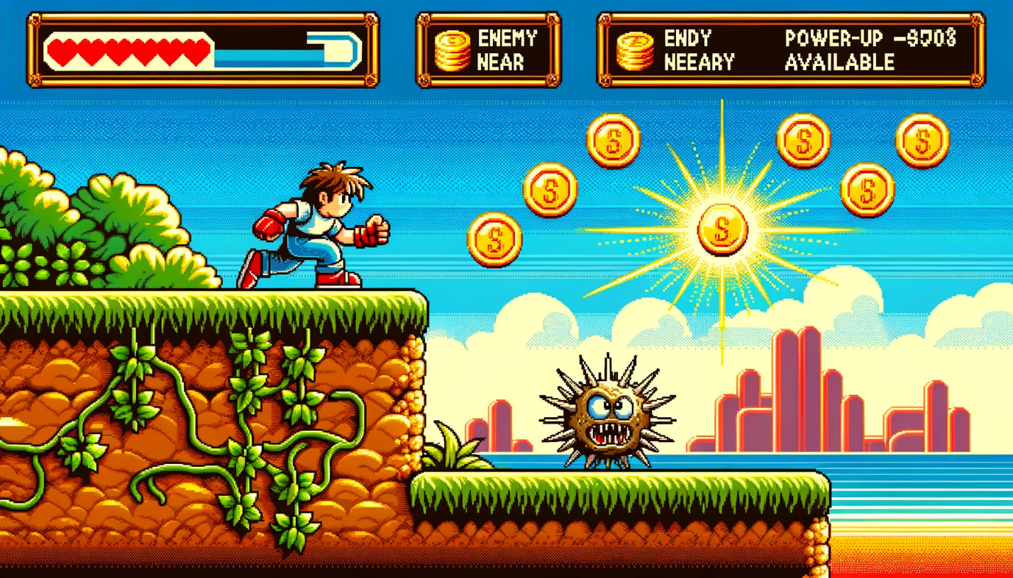

1. Autonomous Car Navigation

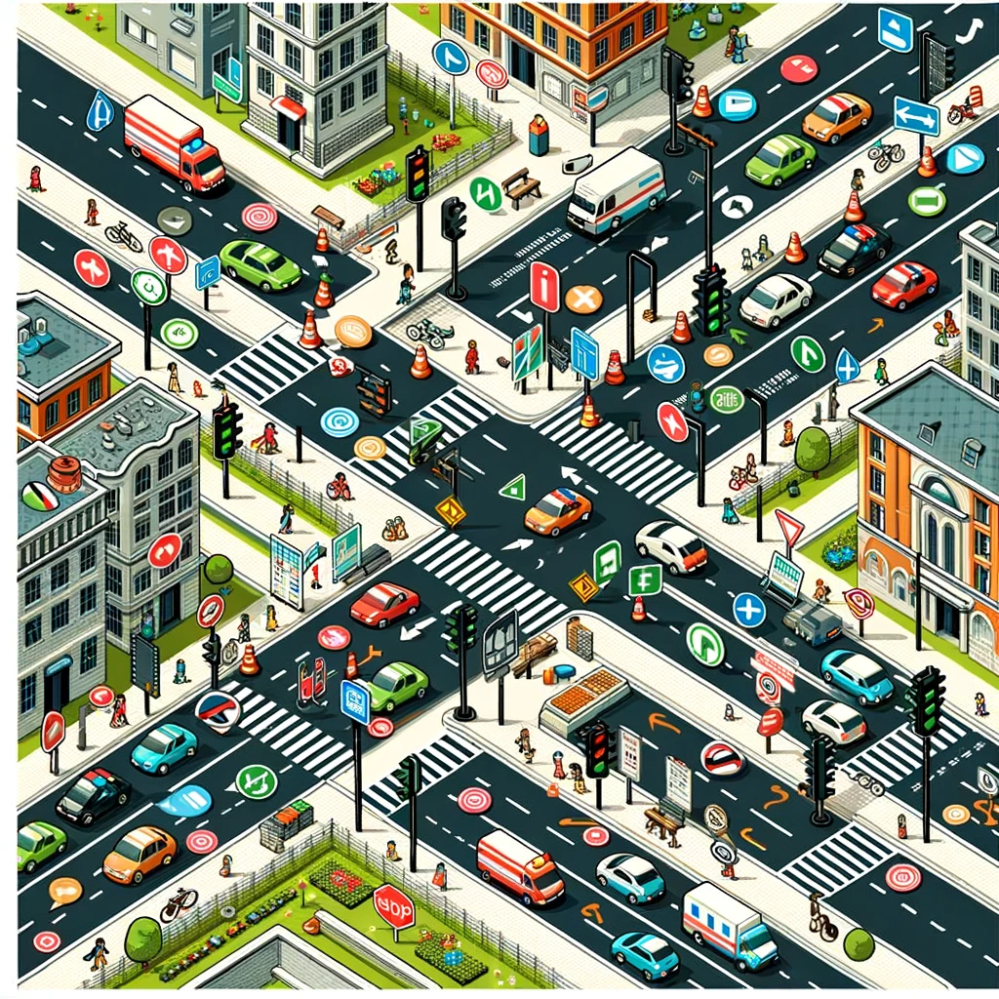

1. Stock Market Trading

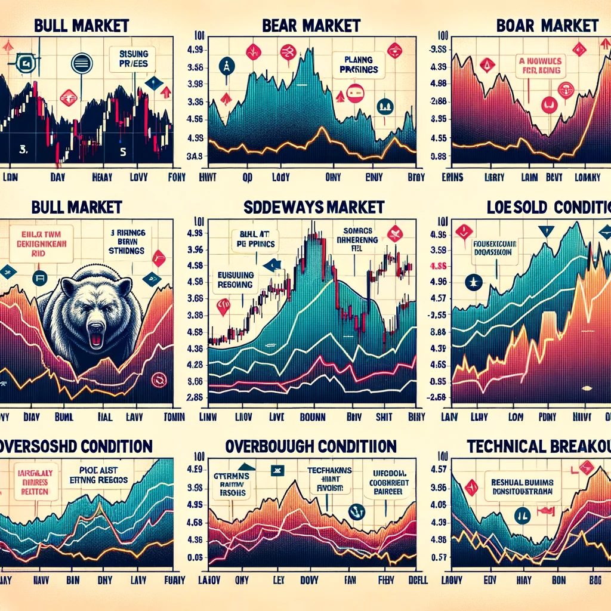

1. Space Exploration

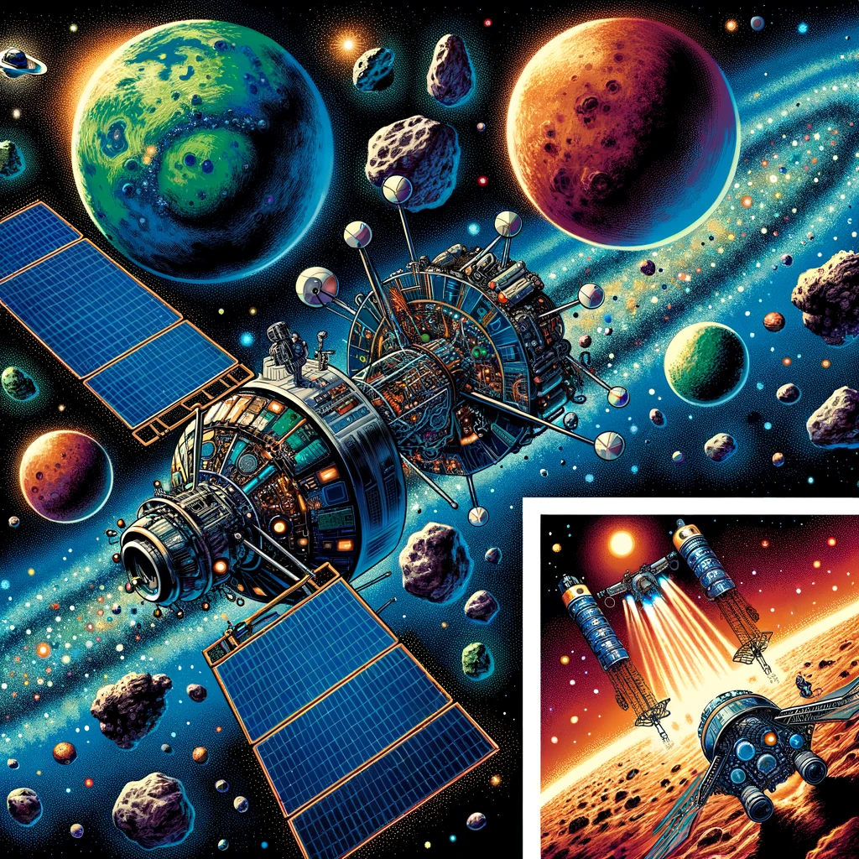

1. Restaurant Management

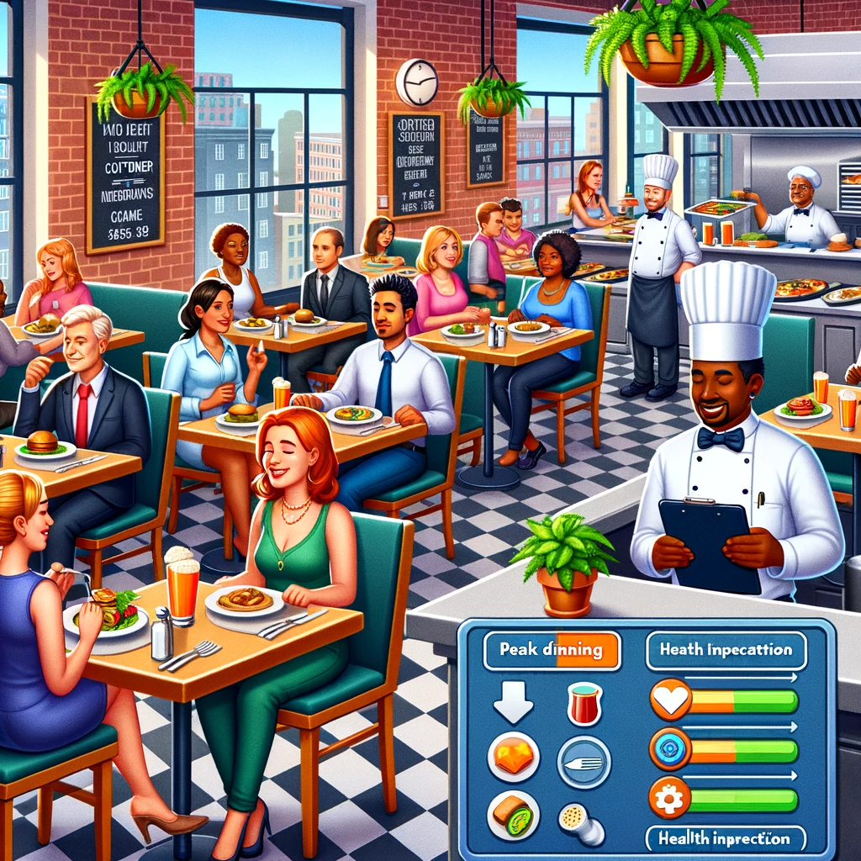

1. Disaster Management

